SOFTWARE REQUIREMENTS SPECIFICATION

**Online Survey System**



**Prepared by: -**

*Daniel Androse P*

*Hari Hara Sudhan J*

*Janarthanan G*

# Introduction

## Purpose

## The primary objective of this document is to outline the requirements for the development of an Online Survey System. It aims to define both the functional and non-functional requirements as specified by the client. This project seeks to create a user-friendly platform for creating, conducting, and analyzing surveys. The system will leverage internet-based technology to streamline the survey process and generate insightful reports.

## Document Conventions

* + - Entire document should be justified.
    - Convention for Main title

Font face: Times New Roman Font style: Bold

Font Size: 14

* + - Convention for Sub title

Font face: Times New Roman Font style: Bold

Font Size: 12

* + - Convention for body

Font face: Times New Roman Font Size: 12

## Scope of Development Project

The Online Survey System is designed to transform the traditional survey methods into a web-based application. This system will enable users to create surveys, distribute them online, collect responses, and generate comprehensive reports. It is intended for various users, including researchers, businesses, and educators. The flexibility of the system allows for easy customization based on specific survey requirements.

The development scope of an Online Survey System involves a comprehensive approach spanning planning, design, development, testing, deployment, and ongoing maintenance. It entails gathering requirements, defining project boundaries, designing intuitive user interfaces, developing robust back-end systems, and integrating various components. Testing phases encompass rigorous checks, including user acceptance testing, to ensure functionality and usability. Deployment strategies focus on efficient launch and post-deployment testing. Ongoing maintenance includes support, updates, and security measures. Adherence to time, budget, resource availability, and scope management ensures successful project delivery. Overall, this scope aims to create an adaptable, secure, and user-friendly platform that revolutionizes traditional survey methods into an efficient web-based system catering to diverse user needs.

**1.4 Definitions, Acronyms and Abbreviations**

JAVA -> platform independence SQL-> Structured query Language ER-> Entity Relationship

UML -> Unified Modeling Language

IDE-> Integrated Development Environment SRS-> Software Requirement Specification

## References

* + - Books: "Survey Methodology" by Robert M. Groves "Web Survey Methodology" by Mario Callegaro
    - Websites:

[**https://www.surveymonkey.com/**](https://www.surveymonkey.com/)

**https://www.alchemer.com/**

# Overall Descriptions

## Product Perspective

Use Case Diagram of Blog Platform

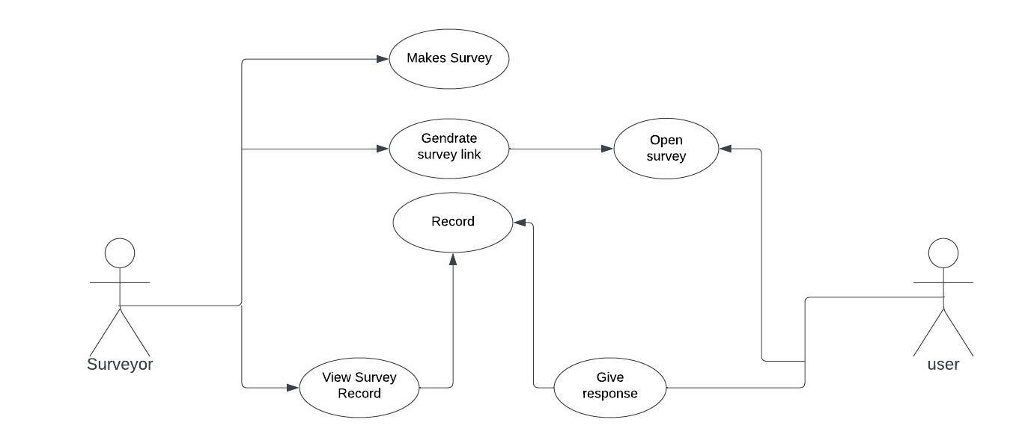

This diagram provides an overview of the main functionalities of the Online Survey System. Users, including survey creators and respondents, interact with the system to create, distribute, and respond to surveys..

## Product Function

Entity Relationship Diagram of Online Survey System.

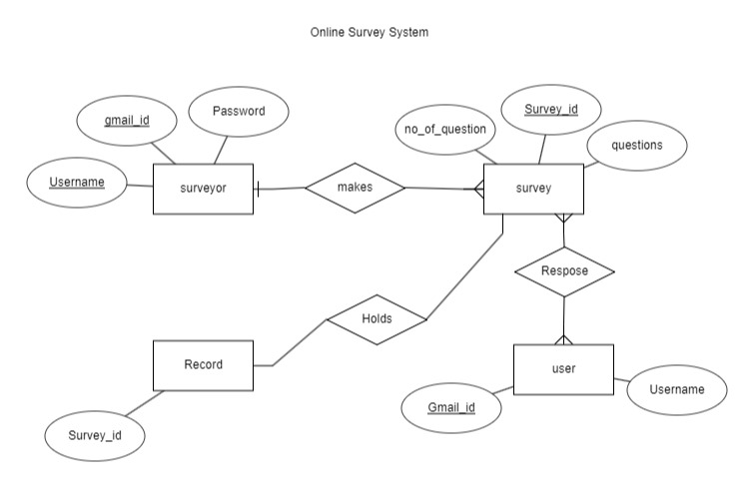

This representation outlines the basic relationships between the main entities in an Online Survey System. In a more detailed ER diagram, each entity would have attributes defining its properties, and relationships would be further expanded to include cardinality and participation constraints. Additionally, entities like choices/options for questions, survey categories, etc., might be included for a more comprehensive representation.

## User Classes and Characteristics

The system caters to two main user classes: Survey Creators and Respondents. Each class has specific functionalities and access rights.Survey Creators:

* Create and design surveys.
* Define survey questions and options.
* Distribute surveys to respondents.
* Analyze survey results.

Respondents:

* Receive and respond to surveys.
* Provide feedback and responses.
* View survey results (if permitted).

Operating EnvironmentThe system will operate in a web-based environment, compatible with major browsers such as Google Chrome, Mozilla Firefox, and Microsoft Edge. It requires an internet connection for survey creation, distribution, and response collection.

## Assumptions and Dependencies

**Assumptions:**

* Users have basic internet browsing skills.
* The system will be available 24/7.
* Survey creators and respondents must have valid accounts.

**Dependencies:**

* Internet connection for survey creation and response collection.
* Browser compatibility with Google Chrome, Mozilla Firefox, and Microsoft Edge

**Internet connection:-**

* + - * Users must have their correct usernames and passwords to enter into their online accounts and do actions

**The dependencies are:-**

* + - * The specific hardware and software due to which the product will be run
      * On the basis of listing requirements and specification the project will be developed and run
      * The end users (admin) should have proper understanding of the product
      * The system should have the general report stored

## Requirement

Software Configuration:

* Front-end: Javafx
* Back-end: MySQL
* Operating System: Windows, Linux
* Database: MySQL
* Development Tools: Eclipse workspace

Hardware Configuration:

* Processor: Dual-core or higher
* RAM: 4 GB or more
* Storage: 100 GB or more

## Data Requirement

The system requires a robust database to store survey information, questions, responses, and user details. The input involves creating surveys and defining questions, while the output includes survey results and reports.

# External Interface Requirement

## GUI

The graphical user interface should be intuitive and customizable. Key features include:

* Survey creation wizard.
* User-friendly survey response forms.
* Dashboard for survey creators to monitor responses.
* Report generation interface

**Survey Creation Interface:** A user-friendly interface allowing administrators to create and design surveys easily. It should include options for various question types, survey formatting, and customization.

**Survey Response Interface:** Clear and intuitive interfaces for respondents to view and respond to surveys. It should guide users through the survey with clear instructions and easy navigation.

**Template:**

* + - The user interface should be able to interact with the user management module and a part

of the interface must be dedicated to the login/logout module

**Login Interface:-**

In case the user is not yet registered, he can enter the details and register to create his account. Once his account is created he can ‘Login’ which asks the user to type his username and password. If the user entered either his username or password incorrectly then an error message appears.

**User Profile Management:-**

Interfaces allowing users to update their profiles, change passwords, or manage account settings.

**Distribution Interface:-**

An interface enabling administrators to distribute surveys via email, social media, or direct links. It should allow for tracking and monitoring survey distribution.

**Reporting Interface:-**

User-friendly interfaces for generating comprehensive reports from survey responses. It should include options for data visualization, filtering, and exporting reports.

# System Features

The Online Survey System aims to provide secure and efficient surveycreation,distribution, and analysis. Key features include:

* User authentication for survey creators and respondents.
* Intuitive survey creation interface.
* Flexible question types (multiple-choice, open-ended, etc.).
* Distribution options (email, link sharing).
* Real-time response tracking.
* Survey result analysis and reporting.

# Other Non-functional Requirements

## Performance Requirement

## Fast and accurate response times.

## Scalability to handle a large number of simultaneous users.

## Robust error handling to prevent data loss.

## Safety requirement

* Regular database backups to prevent data loss.
* Power backup (UPS) in case of power supply failure.

## Security Requirement

* + - Secured database storage.
    - User authentication for data access.
    - Encryption for sensitive data.
    - Protection against password hacking.

## Requirement attributes

* Open-source nature of the project.
* User-friendly installation process.
* Regular updates and maintenance.

## Business Rules

* Adherence to survey creation policies.
* Clear cost structure for premium features.
* Respect for respondent privacy.

## User Requirement

**Administrator/User Creating Surveys:**

* User-Friendly Survey Creation: An intuitive interface allowing administrators to easily create, edit, and organize surveys. Drag-and-drop functionalities or templates can streamline the process.
* Question Variety: Ability to add various question types (multiple-choice, open-ended, Likert scales, etc.) with options for customization.
* Survey Customization: Options to customize survey appearance, themes, branding, and layout according to specific needs.
* Distribution Control: Tools to manage survey distribution channels (email, social media, direct links) and track responses in real-time.
* Report Generation: Capabilities to generate comprehensive reports and analytics from collected responses, including visual representations for easier analysis.

**Respondents Participating in Surveys:**

* Accessible Surveys: User-friendly interfaces guiding respondents through surveys, ensuring clear instructions and easy navigation.
* Compatibility: Surveys accessible across various devices (desktops, laptops, tablets, smartphones) and browsers for wider participation.
* Anonymity and Privacy: Assurance of respondent anonymity and privacy protection while providing honest feedback.
* Progress Tracking: Visual indicators showing survey completion progress and estimated time for completion.
* Confirmation and Thank You: Confirmation messages upon survey submission and thank-you notes to respondents for their participation.
* Notifications: Email or system notifications for important updates, survey deadlines, or system maintenance.

# Other Requirements

## Data and Category Requirement

* Different categories of surveys (academic, business, etc.).
* Categorized storage of survey data.

## Appendix

A: Admin, Abbreviation, Acronym, Assumptions B: Browser, Business rules C: Class diagram, Client, Conventions D: Data requirement, Dependencies G: GUI K: Key O: Operating environment P: Performance, Perspective, Purpose R: Requirement, Requirement attributes S: Safety, Scope, Security, System features U: User, User class and characteristics, User requirement

This format organizes the terms alphabetically and groups them under the respective letters as per your specified structure.

## Glossary

The following are the list of conventions and acronyms used in this document and the project as well:

* + - Administrator: A user with administrative privileges.
    - User: An individual interacting with the system.
    - Client: The intended users of the software.

## Class Diagram

## Each class would have attributes defining their properties.

## Relationships would include cardinality (how many instances of one class relate to instances of another) and multiplicities.

## Additional classes or associations might be included for features like question types, survey categories, etc.

## 

## Conclusion

This template provides a structured framework for capturing the requirements of an Online Survey System. Customize it further based on the specific needs and features of your project.

